Clockwork Banishing Ritual
0. Stand in the center of the room if you’re alone and in a circle if in a group and face East (today, just stand where you are).
1. While facing East, use the index finger of your right hand to ‘draw’ a pentagram (that of Banishing Earth) in front of you in the air.
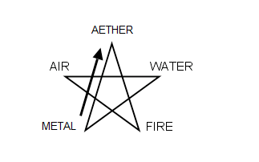
2. Stab the center of the pentagram with your finger, imagine it filling with gold light, and say, Master of Air. The pentagram will turn clockwise.
3. Turn to the South. Do the same, but say: Purifier with Fire.
4. Turn to the West. Do the same, but say: Purveyor of Steam.
5. Turn to the North. Do the same, but say: Forger of Metal.
6. Turn to face East.

Extend your arms in the form of a cross say…
Before me the Airship Captain;
Behind me the Inventor;
On my right hand, the Blacksmith;
On my left hand, the Alchemist;
For about me flames the Pentagram,
And in the column stands the six-rayed Star.
7. Tap yourself on the third eye (just above and between the eyes) 3 times to open it, and say: The Temple of the Clockwork Alchemist is now open.
To close the temple, repeat the ceremony but reverse directions (i.e. start in the North and end in the East). Imagine the pentagrams turning counterclockwise Tap yourself on the third eye 3 times, and say: The Temple of the Clockwork Alchemist is now closed.

